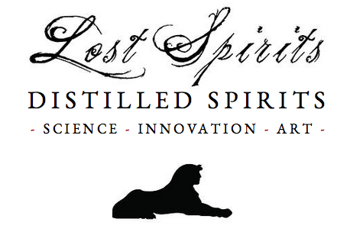

Lost Spirits
The model 1 - 21st Century Oak Aging
White Paper
April, 2015
Contents

3. Introduction

4. Implementations

6. Aged Spirits Overview

8. The Technology

10. Volatile Properties
Volatile Chemical Markers in Aging
Mass-Spectrometry Comparisons
- Lost Spirits Colonial vs. 33-Year Aged Control

14. Semi-Volatile Properties
Mass-Spectrometry Comparisons
- Lost Spirits White Rum
- Lost Spirits Model 1 - Aged Rum
- 33-Year Aged Control

17. Technical Limitations and Workaround

19. Key Advantages

.
Introduction

The Model 1 represents a major breakthrough in distilled spirits production. It is a compact and portable skid-mounted chemical reactor. When charged with oak blocks and freshly-distilled alcoholic spirits, the reactor uses energy in various forms to trigger the myriad of chemical reactions that take place in a barrel as spirits age. The new technology has been proven so effective that in 6 days, it can make a spirit with a chemical profile closely approximating the chemical signature of a 20-year-old product. The results have been verified by GC/MS (the gold standard in forensic chemistry) conducted at an independent and accredited laboratory.

People have been unsuccessfully attempting to rapidly mimic the effects of barrel aging since the dawn of science. Given the nature of the new technology, and the potential impact it could have in the market, it is understandable that some people may meet these claims with healthy skepticism. The purpose of this paper is to explain what we have done, how we believe the chemistry is working, and to publish the empirical evidence that supports the claims.

The underlying, patent pending, technology was developed by Bryan Davis on a prototype system at the Lost Spirits test distillery, located in a rural California. Five beta-test Model 1 reactors will be leased to other distilleries this summer. Once the software and hardware is fine-tuned, the reactors will become widely available in 2016.

Implementations

Lost Spirits aging technology was developed to produce spirits capable of competing in the highest quality segment of the market. As this white paper will demonstrate, the technology not only triggers the chemical changes taking place in traditionally aged spirits, in some ways it can exceed the performance of traditional aging.

The system can build spirits with the same chemical signature seen in classical aging. However, with proper tuning, it can do so without the hindrance of excess ethyl acetate build up, a solventy aroma flaw sometimes caused as a consequence of age. It can also build a slightly denser concentration of long-chained esters, responsible for the distinct finish or aftertaste found in the most prized spirits.

In addition to subtle quality gains, the technology eliminates decades of aging time and the accompanying evaporation losses associated with traditional cask aging. The rapid turn-around time greatly reduces costs associated with warehousing. Furthermore, the technology allows products to be produced at significantly lower costs by eliminating the financing charges and evaporation losses associated with long aging times. The reduction in cost can be as much as 75% for fully mature spirits (20 years or greater).

The technology, also presents an unprecedented opportunity to rapidly prototype. This capability enables the distiller to run hundreds of tests in advance of aging a production spirit. This new ability will allow distillers to take risks and experiment in ways that were previously not economically possible. In the past, a distillery had to invest millions in aging stock to make a mature 20-year-old product. Because of the massive cost associated with such long production times, experimentation was rare.

The new technology also offers an exciting opportunity to recreate spirits lost to the past. When the technology is tuned, using chemical markers identified by GC/MS, it can be used to recreate a specific chemical signature of a long-lost product. Though it has not been done yet, it is anticipated that in the near future the rapid prototyping aspect of the technology will be employed to bring back “lost spirits” like the legendary Wray & Nephew 17, used to create the Mai Tai cocktail, or the over 100-year old whiskey found on Earnest Shackelton’s abandoned ship.

In an infinitely more practical--if less exciting--application, the technology may be employed to “complete” partially mature spirits. For example, a company could purchase immature 2 to 3 year-old rum or whiskey, and then employ the technology to rapidly bring it to full maturity.

At present, the technology has been implemented to produce the Lost Spirits Colonial Inspired Rum, which has been met with high critical praise.
Aged Spirits Overview

Aged spirits are highly complex systems. Mature rum can contain as many as 500 unique chemical compounds. The majority of these compounds contribute to the flavor, aroma, and body of the spirit in meaningful ways. The majority of these compounds are also made in the cask through a chemical reaction called esterification.

The fresh white spirit contains some short-chained carboxylic esters, responsible for the fruit aromas found in fresh spirits. The white spirit also contains short-chained fatty acids. The fatty acids, given enough time in the barrel, will esterify into additional fruity flavors (esters) during aging.

The aging process itself works in two very distinct ways, extraction and esterification. Extraction is the process of obtaining new compounds from the oak, including fatty acids and phenols. Esterification is the chemical reaction triggered in the barrel, which binds the acids and phenols to alcohols, thus forming the fruity and aromatic esters largely responsible for the flavors associated with maturation.

The extraction happens because polymers in the wood, damaged by heat from the charring or toasting process, subjected to the ethanol as a solvent slowly leach aldehydes, precursor acids, and phenols into the spirit. The aldehydes flavor the spirit with woody, toasty, smoky, and vanilla-like flavors. The acids and phenols leached from the oak are precursor compounds that can later esterify into other flavor molecules.

Part of the reason the spirits aging process has proven so difficult to accelerate is because the extraction process does not appear to be linear. In other words the addition of more oak surface area seems to extract more of the first compounds to leach from the oak as opposed to a proportionate mixture of the compounds extracted over time.

Esterification is the chemical reaction largely responsible for forming the chemicals in distilled spirits associated with the flavor and aroma of maturity. Esterification happens when an alcohol, phenol, or weak acids bond together. The resulting products of this reaction (esters) usually have pleasant flavors and aromas.

During the aging process, precursor acids carried over from the fermentation bind to alcohols to form the bulk of the short-chained esters (volatile esters) responsible for much of the fruit flavors of the spirit. Additional acids extracted from the oak bind to alcohols to form the medium-chained esters (semi-volatile esters) responsible for mid-palate fruity flavors, as well as some earthy and nutty flavors.

In the later stages of maturation, short-chained and medium-chained esters bind to other alcohols, phenols, or acids to form long-chained esters. The long-chained esters are responsible for the sweet honey, floral, and tobacco flavors found in the best spirits.

During this process off-flavors also diminish or vanish. This happens because the precursor acids tend to have unpleasant aromas. For example, butyric acid, a common acid found in white rums, has the characteristic aroma of vomit. However, when it is esterified with ethanol the resulting ester, ethyl butyrate, has the aroma of a pineapple.

The Technology

The patent-pending rapid-aging technology, developed at Lost Spirits, functions by forcing the same reactions that happen naturally in the cask. The Model 1 reactor functions in three distinct phases. Phase one is esterification of volatile acids found in the white spirit. Phase two extracts the flavoring compounds from the oak and additional precursor acids and phenols. The final stage in the process forces components of the oak extractives to esterify and ultimately bond with the products of the first phase to create long-chained complex esters.

Phase one in the series forces the esterification of short-chained fatty acids. These are the acids produced during the fermentation and carried over the still into the spirit. At the end of this phase, the spirit contains a similar concentration of short-chained fruity esters as a mature spirit. However, it is far from complete. It lacks most of the medium-chained esters, phenols, and aldehydes associated with a mature spirit.

The second phase works by energetically breaking apart the polymers in the oak. The process is tuned to yield a range of oak extractives that mirror the compounds extracted slowly over the course of 20 years in a barrel. At the end of this process, the spirit has the majority of the wood-derived aldehydes present in a mature product. However, it also contains significant amounts of medium-chained acids with unpleasant flavors.

The third, and final phase, forces the medium-chained acids, the phenolic acids and phenols extracted from the oak to esterify. In this final stage, simple esters form rapidly. As the hours progress, some of the simple esters begin binding to other precursors, creating the long-chained esters associated with spirits aged for decades.

Once the product emerges from all three stages, it possesses a chemical signature nearly identical to a conventionally aged spirit. In other words, the resulting product essentially is the same thing, molecularly, as a spirit that has been aged in a cask for decades.
Volatile Properties

The volatile properties of distilled spirits change in two significant ways during cask aging. Acetyl, extracted from the oak, builds up significantly during the aging process. Simultaneously, trace amounts of volatile acids, present from the fermentation, convert into highly pungent esters.

While we are interested in acetyl build-up as a major contributor to the flavor associated with maturity, ethyl butyrate, ethyl propanoate, ethyl octanoate and several other volatile esters are also of interest. These trace esters produce desirable flavors detectable by humans in the 1-10 parts per-billion range (ppb). Therefore, they are contributing significantly to the flavor in mature spirits.

During both the cask aging process and the Lost Spirits method, increases in concentration of almost all esters present in the white spirit are observed. Because the volatile acid counterparts of these esters produce raw, undesirable aromas, their conversion to volatile esters is a major factor in the quality improvements seen in mature spirits.

As the chromatograms in this section will demonstrate, the Lost Spirits method, coupled with an optimized fermentation and distillation regime, approximates the target concentrations of the markers in the control rum.

Volatile Chemical Markers In Aging

Acetyl concentrations multiply significantly during the aging of distilled spirits. The compound may be used as a chemical marker to “date” spirits relative age. The following graph shows a comparison between white rum (from Lost Spirits), the same rum aged using the new technology (labeled Lost Spirits Colonial), and a 33 year-old control rum. As the following graph demonstrates, the Lost Spirits Rum has an acetyl peak concentration roughly 60% that of the 33 year-old control. Placing the relative age (by chemical marker concentration) of the Lost Spirits rum somewhere in the 15-20 year range.

NOTE: The Lost Spirits Rum does not contain any additives. Any marker concentrations shown are produced naturally from chemical reactions taking place during oak induced aging.

Mass Spectrometry Comparisons

As shown previously, the Lost Spirits’ system produces acetyl concentrations comparable to between 15 years and 20 years in oak. However, this is a relatively incomplete picture. To gain a better understanding, we have used mass spectrometry to produce a chemical fingerprint of the volatile range compounds in the aged rums. The following overlaid chromatograms provide empirical evidence of the systems efficacy in the VOC range. The striking similarity of the fingerprints is immediately apparent. The performance of the Lost Spirits’ system is also apparent in terms of the relative concentrations of desirable target volatile esters.

The following page contains an offset chromatogram overlay of the Lost Spirits Colonial Inspired Rum compared against the 33 year-old control rum. Several key performance indicators are identified, and their relative concentrations are clearly visible on the overlays. You will notice that the two are remarkably similar.

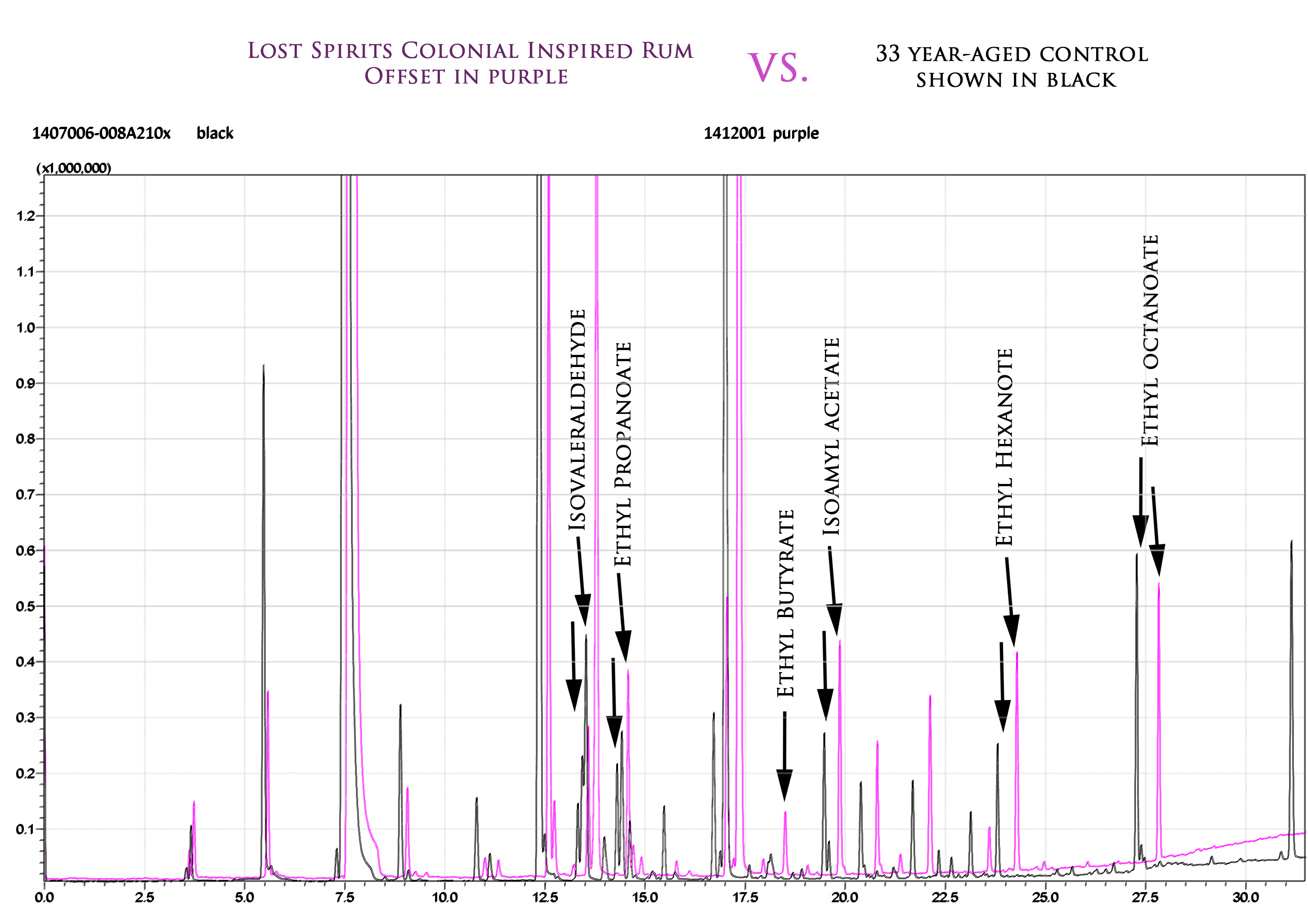

List of target high potency compounds developed (or magnified) during traditional spirits aging.

Isoamyl Acetate
Aroma: Sweet banana, fruity, with a ripe estry
Human detection threshold: 2ppb

Ethyl Octanoate
Aroma: Waxy, sweet, pineapple, fruity, with creamy dairy
Human detection threshold: 15ppb

Ethyl Butyrate
Aroma: Fruity, Juicy Fruit, pineapple, cognac
Human detection threshold: 1ppb

Isovaleraldehyde
Aroma: Chocolate, peach, fatty
Human detection threshold: 1ppb

Ethyl propanoate
Aroma: Sweet fruity rum, Juicy Fruit, grape, pineapple
Human detection threshold: 10ppb

Ethyl Hexanoate
Aroma: Sweet fruity pineapple, waxy green banana
Human detection threshold: 1pp
Semi-Volatile Properties

Empirical evidence of spirits aging is most significant in the semi-volatile range. As spirits age in the cask, they extract trace concentrations of potent, wood-derived, aromatics like vanillin and related syringaldehyde, sinapaldehyde, benzylaldehyde, and coniferaldehyde, along with smoky phenols and benzoic acid. These compounds are classified as semi-volatile, due to their elevated boiling points.

The three chromatograms in the following section provide concrete empirical evidence showing that the Lost Spirits system is capable of not only building the density of semi-volatiles, but also of producing a nearly identical fingerprint to 20 years in the cask, as compared to the 33 year-old control.

NOTE: The 33-year-old control used as a gold standard in the experiments was shown “forensically” to contain added sugar. Unfortunately, a portion of the chromatogram is obscured by the large mass of caramelized sugar (which is highlighted below).

NOTE 2: The process of confirming the sugar addition was quite exhaustive. It included both the utilization of library chromatograms, of aged malt whiskies, as well as the qualitative identification of sucrose. The library chromatograms showed a similar fingerprint in the obscured area of the 33 year-old sample to that of the Lost Spirits Rum. This data is available upon request.

Lost Spirits White Rum (left) vs. 33-year-old control rum (right)

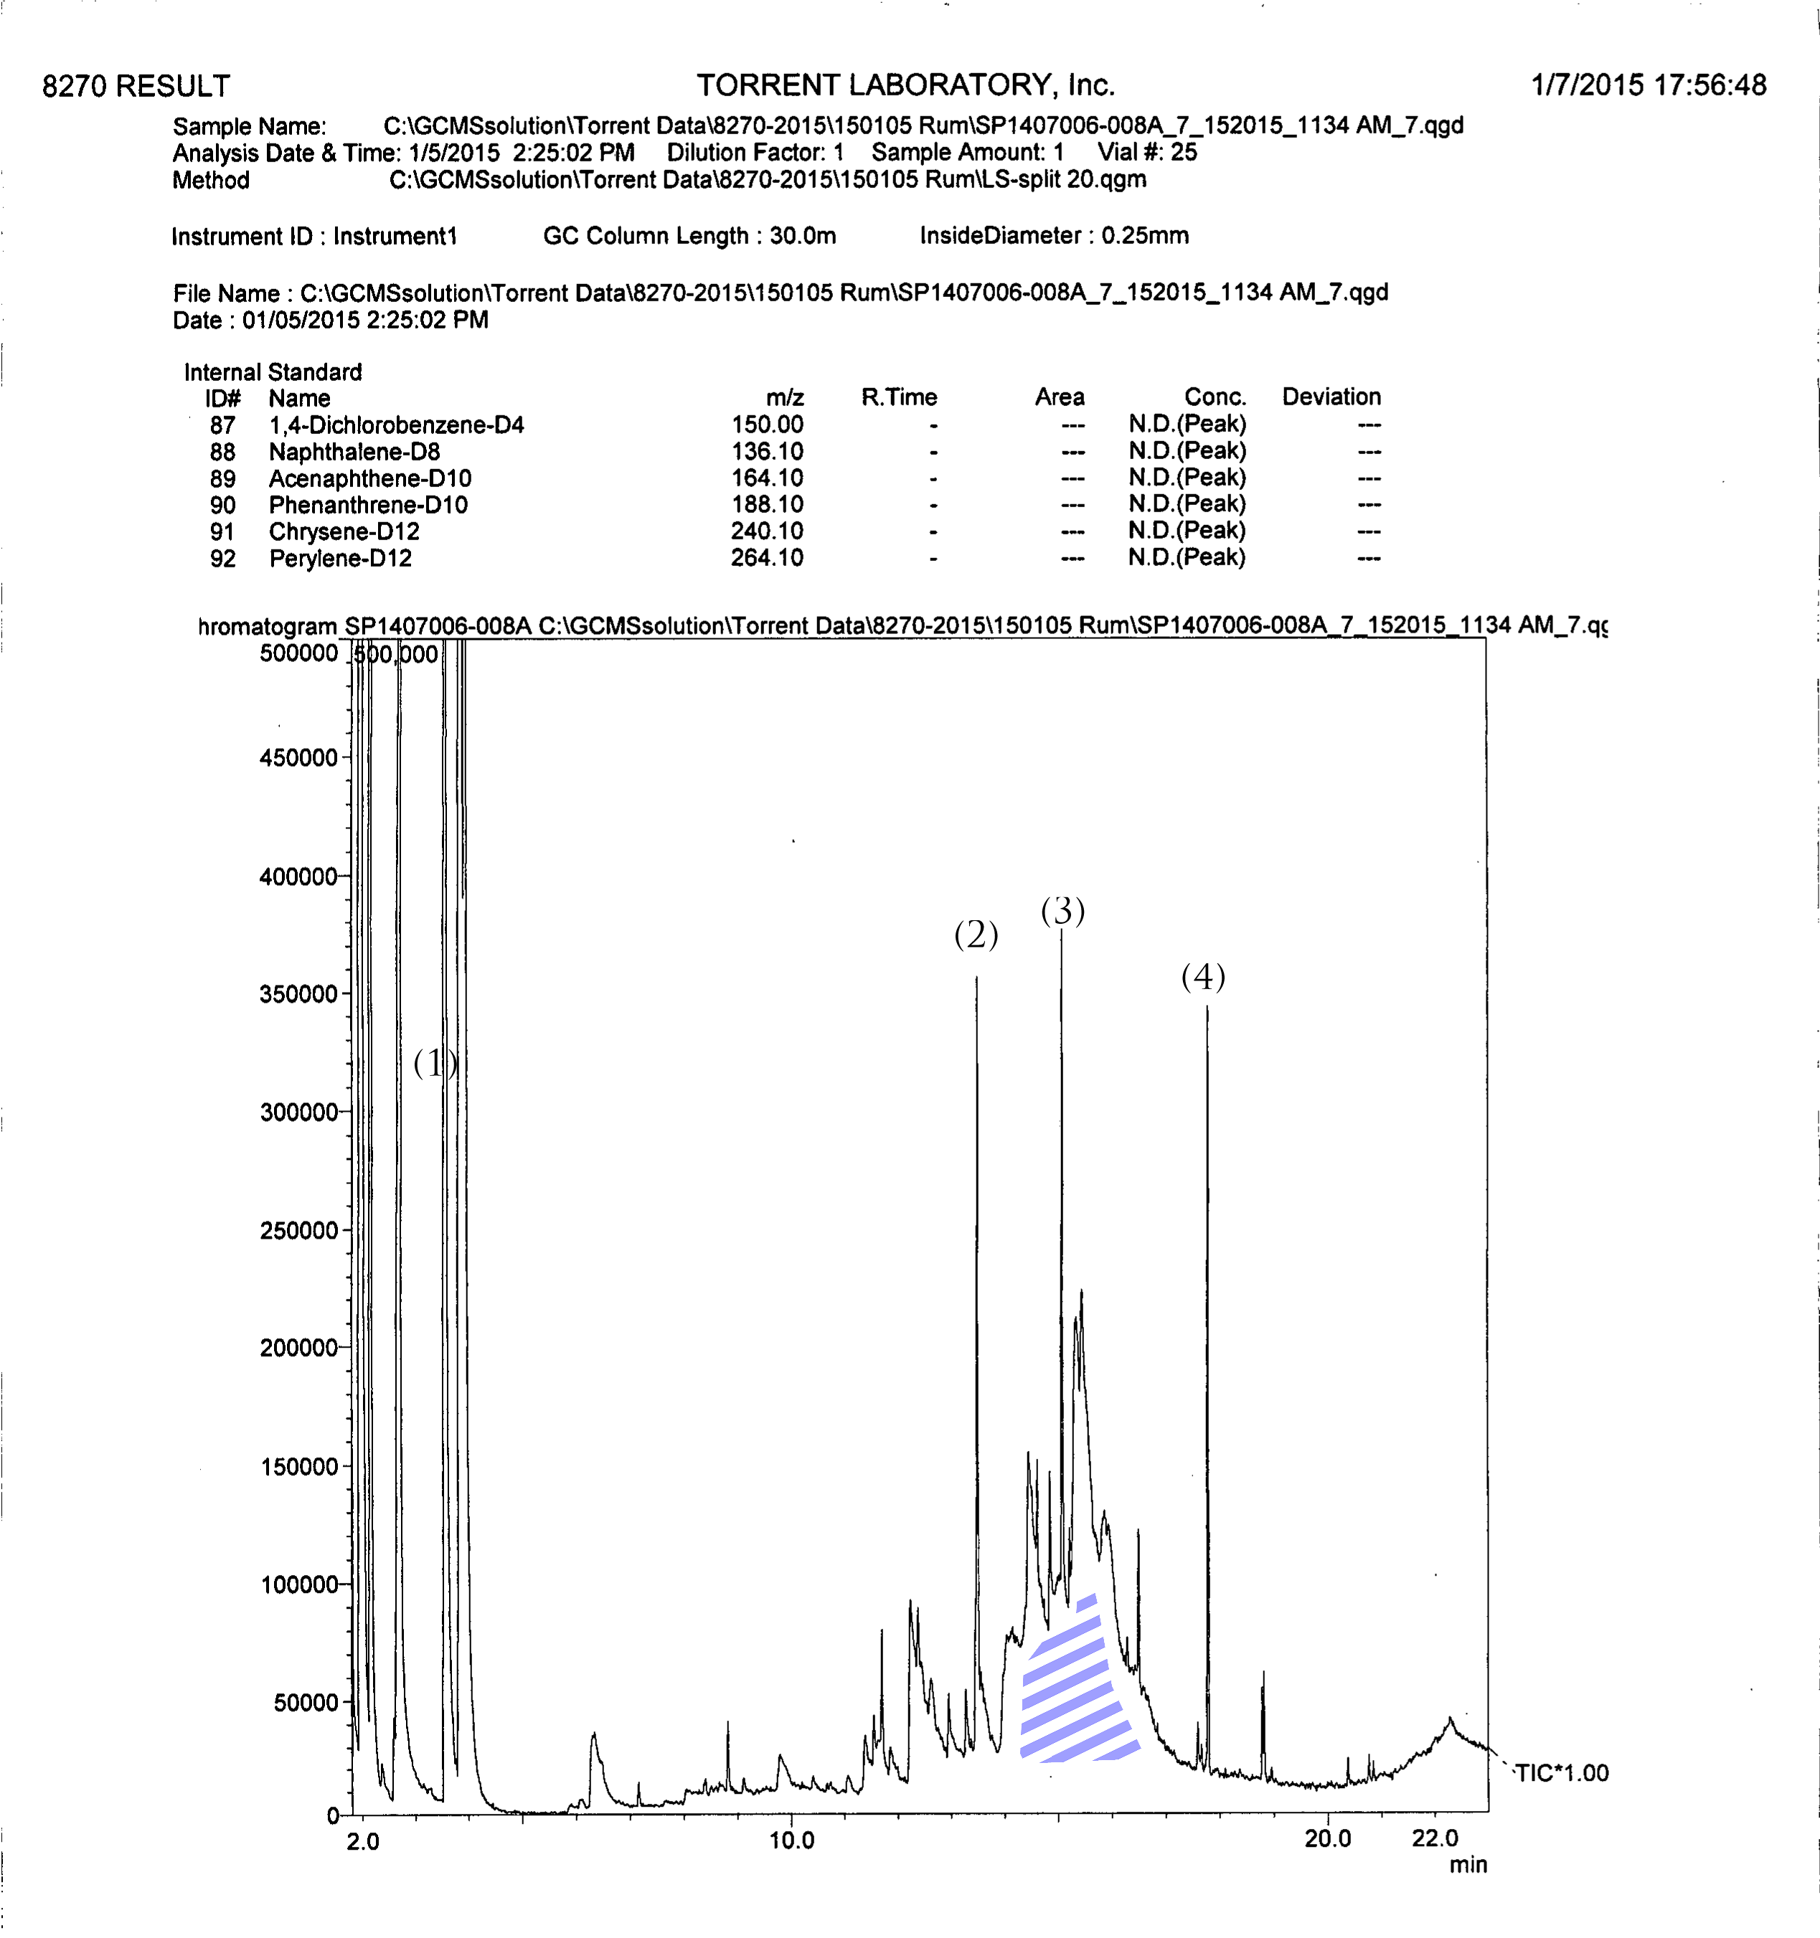
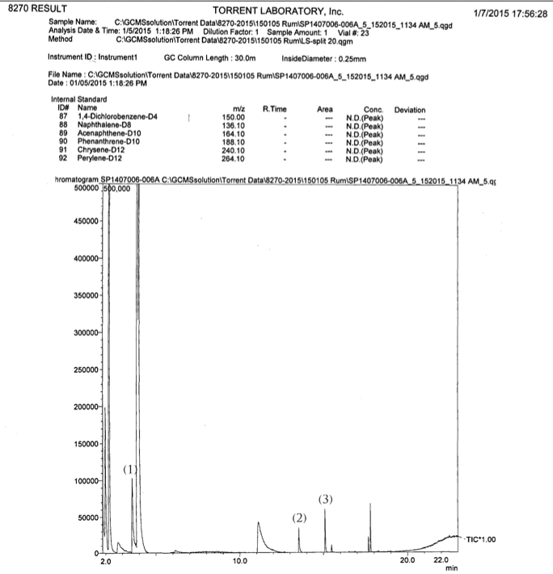

Lost Spirits Colonial Rum (left) vs. 33-year-old control rum (right)
Added sugar
(sucrose)
(1) Acetyl (2) Ethyl decanoate (3) Ethyl dodecanoate (4) Sinapaldehyde
NOTE: Relative peak heights of all 4 key markers show 60% +/- peak height development in the Lost Spirits rum as compared to the 33-year-old control, chemically equivalent to 15-20 years in oak.
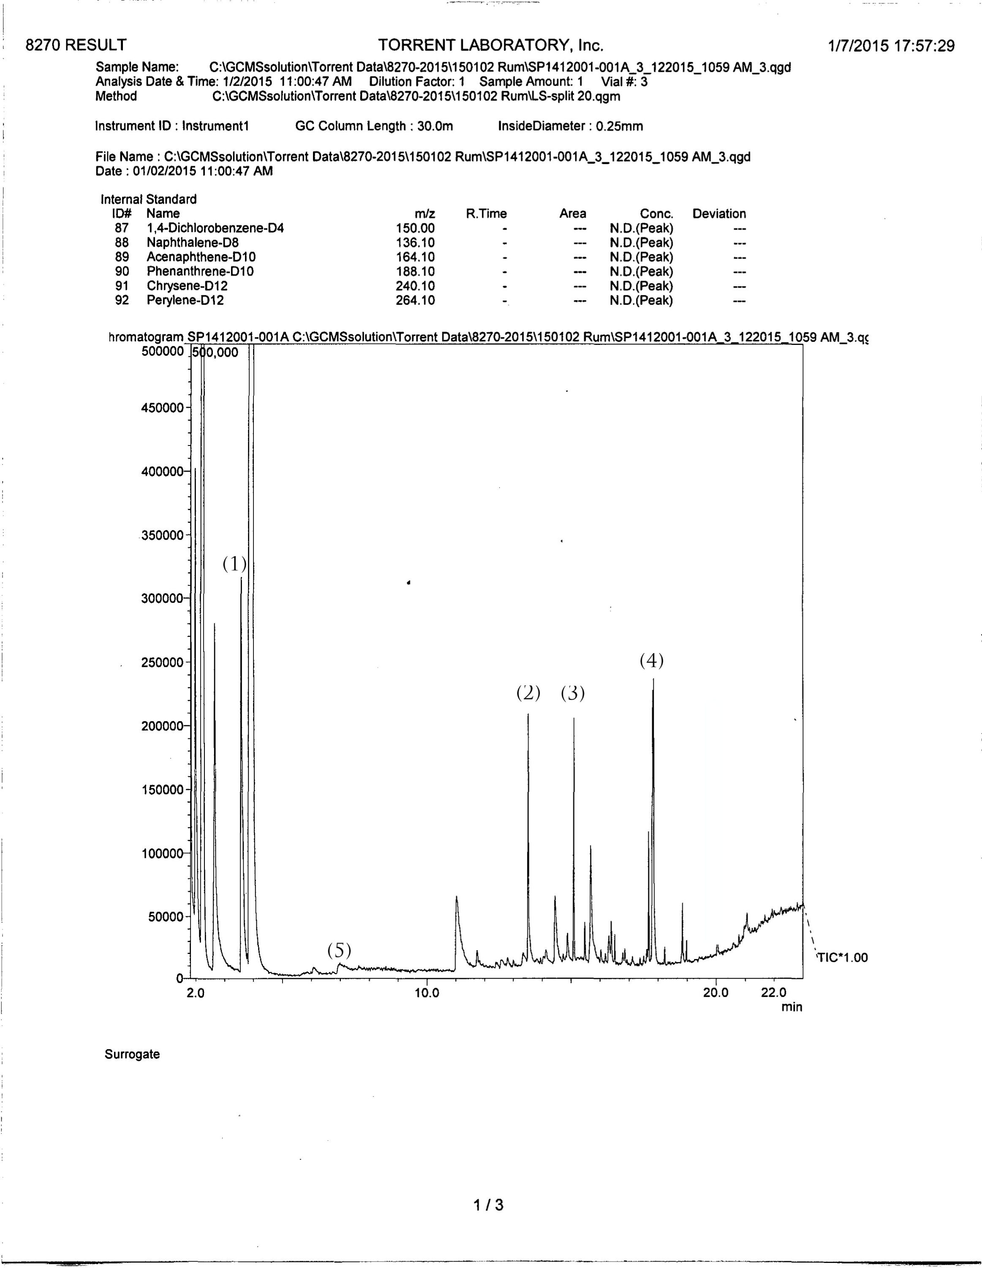
(1) Acetyl (2) Ethyl decanoate (3) Ethyl dodecanoate (4) Sinapaldehyde
Added sugar
(sucrose)

Technical Limitations & Workaround

While the Model 1 reactors are capable of closely approximating the chemical signature (composition) of 15-20-year-old rum, the process appears to be limited to that age range. If the product is processed in the reactors for longer time intervals, the relative proportions of the flavor molecules go out of sync with the signature of the control product.

It appears that to approximate the concentrations associated with a longer age (20-40 years in the cask) the evaporation losses will need to be recreated. Had the Colonial Inspired Rum been subjected to the 50% evaporation losses that the 33 year-old control experienced, the two semi-volatile chromatograms would have aligned almost exactly in both concentration and signature (as opposed to just signature).

Technically, a workaround is possible – but not without an “angels share” (evaporation losses). The system could include a fourth reactor that uses a special membrane and vacuum to remove water and ethanol without removing the aroma and flavor compounds. This would cause the peak values to increase proportionately to the amount of ethanol and water extracted. The membrane could also be made of oak. However, this workaround has the economic disadvantage of adding back the significant cost associated with the evaporation. While in specific applications this retrofit may be desirable, such as cloning the exact profile of an extinct product, the beta-test Model 1 will not have this capability, and is limited to approximating 15-20 years of maturity.

NOTE: If this workaround ever becomes standard on a Lost Spirits reactor, the vacuum extracted ethanol and water could be condensed and sold for neutral spirits production, allowing some of the lost economic value to be recaptured.

Key advantages:

- Time to market was vastly improved from 15 – 20 years to 6 days, with no compromise in chemical / aroma profile

- 99% of the evaporation losses during aging (up to 50% volume over 20 years) were eliminated

- The process provides major R&D advantages, allowing hundreds of tests to be run concurrently

- The reactors should function seamlessly in rum, whiskey, brandy, agave spirits, ETC

http://www.leffingwell.com/esters.htm

